Ritushree shukla

Dell

Swagger & NODE.JS

Contents

**Initial Environment Setup** 2

**Swagger Server Code: Build, Deployment and Testing** 3

Code Build & Deployment Methods 4

API Testing 5

**Server code: Custom Response** 9

Implementation 9

References 10

# **Initial Environment Setup**

Pre-requisites:

* Java JDK 7 & above - <http://www.oracle.com/technetwork/java/javase/downloads/index.html>
* Atom IDE- <https://atom.io/>
* Node - <https://nodejs.org/en/download/>
* System variable names NODE_PATH with value

C:\Users\...\AppData\Roaming\npm\node_modules

C:\...\nodejs\node_modules\npm\node_modules

* Cassandra DB- <http://cassandra.apache.org/download/>
* Set env variable CASSANDRA_HOME= {Your installation path}\DataStax Community\apache-cassandra\
* Nginx- <http://nginx.org/en/download.html>
* Rest Client - <https://chrome.google.com/webstore/detail/postman/fhbjgbiflinjbdggehcddcbncdddomop>
  + Install the Postman Chrome plugin from the above link
* SET PATH to

C:\Users\...\AppData\Roaming\npm; C:\...\nodejs\node_modules\npm;

C:\Users\...\AppData\Local\atom\bin ;C:\nginx-1.10.1\nginx-1.10.1

# **Swagger Server Code: Build, Deployment and Testing**

1. Import the YAML file in the Swagger Editor UI - <http://editor.swagger.io/#/>

(File 🡪 Import a File🡪Choose File). Refer References section for a sample YAML

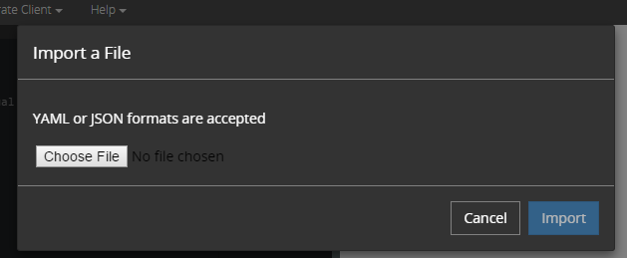

1. After importing, Swagger Editor displays the file content along with the API Docs based on the specifications in the YAML file.

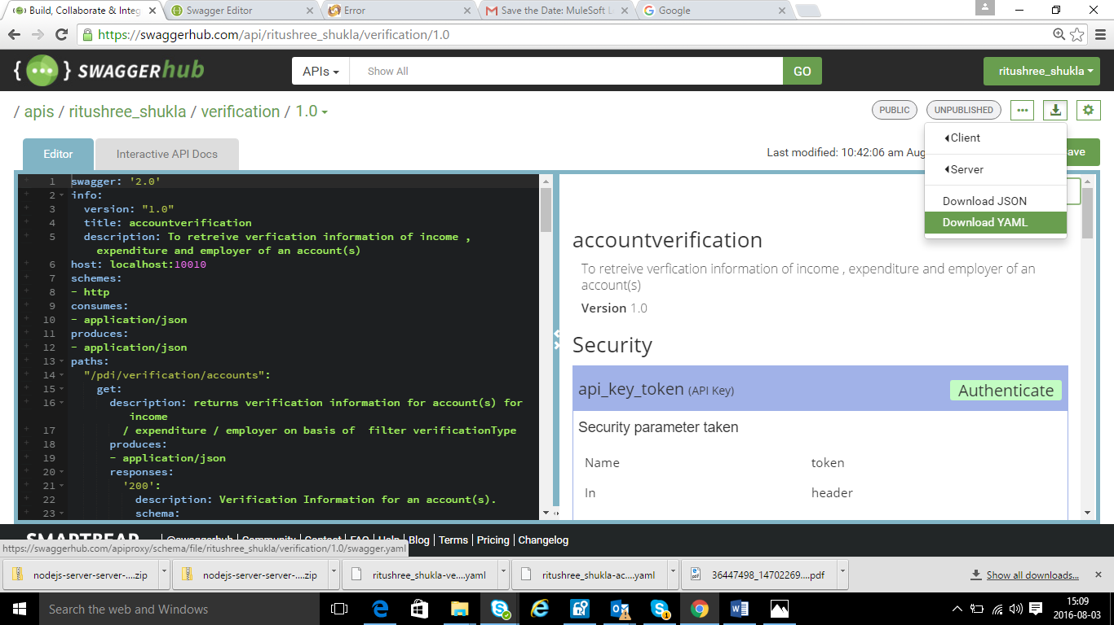

1. Select the preferred laguage for generating the Server code from the Swagger Editor UI. (Generate server 🡪 Node.js). The swagger server code of the chosen language gets downloaded.

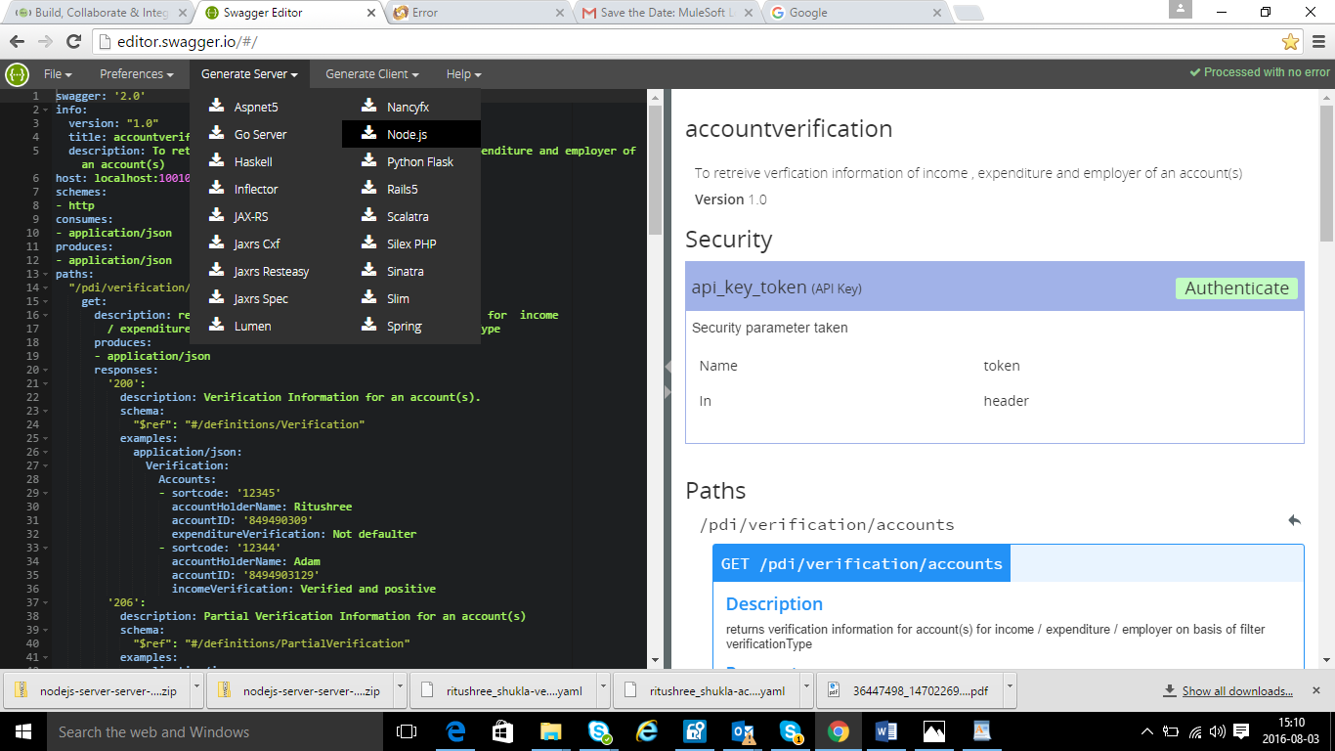

1. Extract the downloaded server code,
2. Import the code in Atom

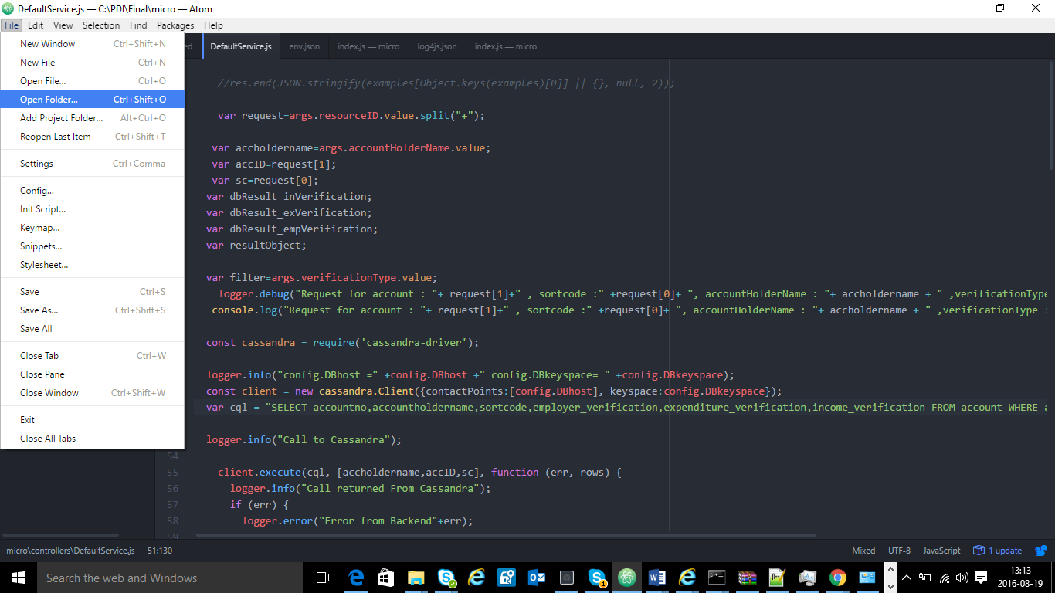

Navigate to the folder where you have unzipped server code.

1. Open the swagger.yaml.And remove the collectionformati line for all array parameters.Else it would fail in validation

collectionFormat: "multi"

### Running

Through command prompt using command

* + 1. Navigate to the extracted server code directory in command prompt and run the following command

***Node index.js***

After completion of the command execution, the code gets deployed and the server starts as shown in the below figure.



### API Testing

For testing the deployed application, submit a GET request through a rest client using the following URI pattern ([http://host:port/{basePath}/customers/{customerid}](http://host:port/%7bbasePath%7d/customers/%7bcustomerid%7d))

A successful response would be displayed as shown below.

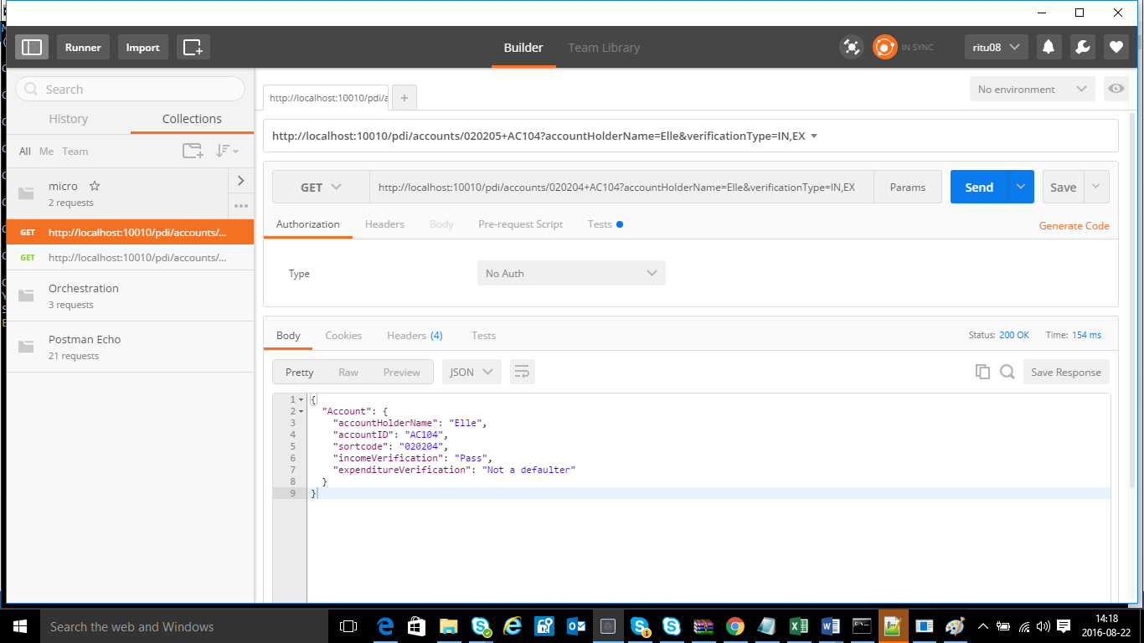

The response is attained by calling the DB

Use the below scripts in DB to enter data

CREATE KEYSPACE pdi WITH replication = {'class':'SimpleStrategy', 'replication_factor' : 3};

CREATE TABLE account (

sortcode varchar,

accountno varchar,

accountholdername varchar,

employer_verification varchar,

income_verification varchar,

expenditure_verification varchar,

PRIMARY KEY (sortcode,accountno,accountholdername));

INSERT INTO account (accountno, sortcode, accountholdername, employer_verification,income_verification,expenditure_verification) VALUES ('AC101', '020202', 'jane', 'Dell UK','Pass','Not a defaulter');

# References

* Sample YAML Definition for Accounts API



* Server Code generated from the Accounts API YAML Definition

